Meeting Opened
- It was determined that a quorum was present.
- Meeting declared open at 1:11pm
- Attending: Doug Burbidge (chair), Elaine Kemp (treasurer), Rohan Wallace (elected board member), Dave Cake (elected board member), Stephen McGlone (elected board member), PRK (elected board member), Sarah Parker (administrator)
- Apologies: Terri Sellen (elected board member), Samara Morgan (elected board member)

In-camera matter
- The refusal of a membership was considered in-camera.

Decision tree
- WASFF considers of prime important the clarity of the decision making process in these situations. In order to present an open process, a decision tree was developed. See below.
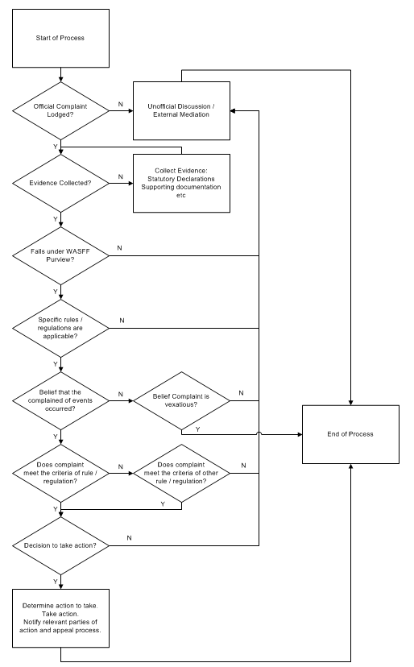

Motion
- EK – Motion: that a particular person be refused membership under regulation 9.4.1 c for the 2013 calendar year. Seconded by PRK. Passed unanimously.

Actions
- DB – We should create public minutes and private minutes.
- Decision tree and decision should be in public minutes. Actual details in private minutes.
- Discussion of whether name of person refused membership should be in public minutes. Decision to exclude the name of the person refused membership from the public minutes.
- RW – also we need to notify the 2013 convention committee.
- PRK – state limit of ban i.e. Swancon
- DC – requests the email states the grounds for the decision and that we are not making assumptions about the person’s character or future actions.
- PRK – let the person know the appeals process
- DB – a Special General Meeting would be required
- RW – which requires 2 weeks notification.
- DB to complete the email ASAP and send out for further editing.

Meeting closed
- The Board Meeting was closed at 2:49pm.

